**IT DEPARTMENT PROCESS**

**TCS CONNECT EMPLOYEE NOTICE LIST PAGE**

1. **Form Design**
2. **Work Order Description**
3. **Table Name**
4. **Conditions**

**Work Order Year: 2018-19**

**TYPE:INTERNAL Created By: RAMESH M**

**1. FORM DESIGN**

**1.1 Employee Notice List Page:**

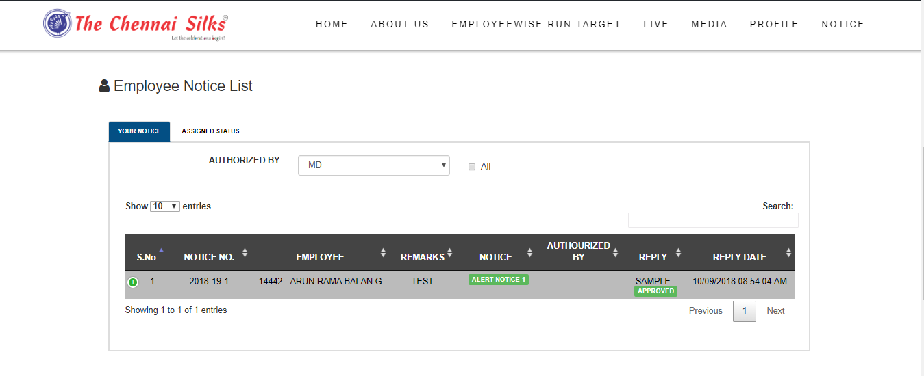

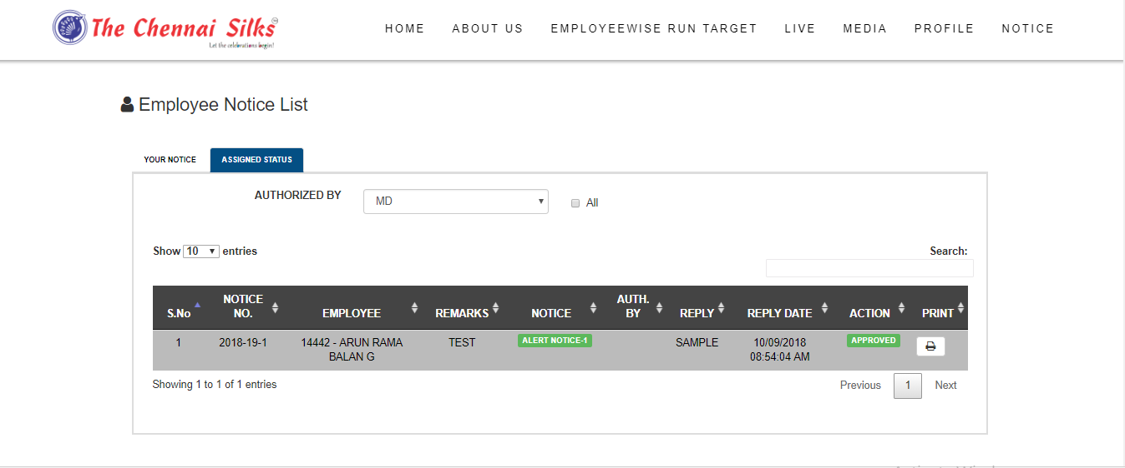

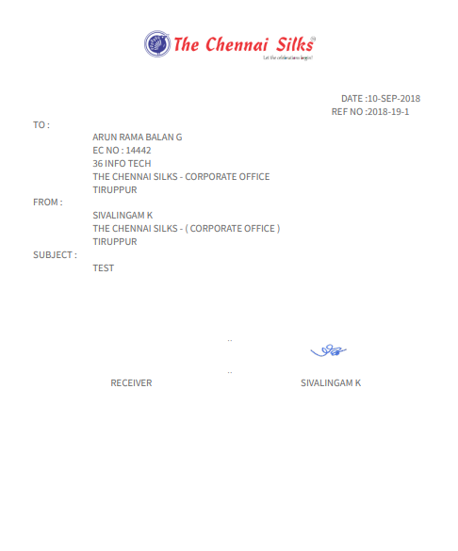

1. **DESCRIPTION**

To list out the employee notice details and their assigned notice details.

**3. TABLE NAME**

**3.1 Main Table:**

* EMPLOYEE_NOTICE_DETAIL

**3.2 Reference Tables:**

* + - employee_office
    - empsection
    - designation
    - employee_salary
    - new_empsection
    - new_designation

**4. CONDITIONS**

* + - 1. DELETED = ‘N’
      2. ADD USER=$_SESSION[tcs_usrcode] for ASSIGNED STATUS
      3. EMPSRNO= $_SESSION[tcs_empsrno] for YOUR NOTICE